Brandon Moore April 3, 2021

CS 499 Artifact 3 Upgrade

Below are the top 10 items sold in the state that had the most items sold and the state that followed. The list is in order according to the SKU. We use our SELECT, FROM, INNER JOIN, and WHERE syntax in combination to analyze which items were the best selling in those stated. This helps us understand where the focus of our products are in those areas.

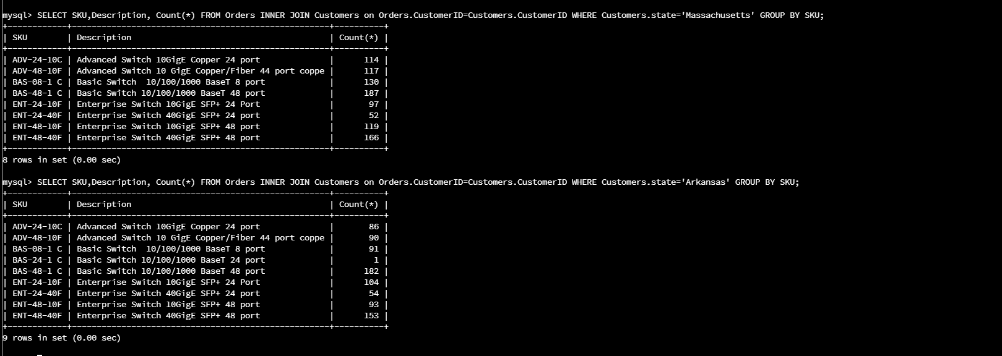

These two queries show us the retuned amount for the each item in the state that had the highest sales. We can use this chart to compare to the actual sales made to see how many of our products were actually kept by the customer. If the customer is purchasing items and only keeping 25% then we need to find out why they don’t wish to keep the products that they purchase. Once we find out the reasons then we can maximize the sales and really bring the company a big profit.